1.Bob is tasked with developing a company's employee record management system. The system needs to maintain a list of employee records using a doubly linked list. Each employee is represented by a unique integer ID. Help Bob to complete a program that adds employee records at the front, traverses the list, and prints the same for each addition of employees to the list.

#include <iostream>
Using namespace std;

Class Node {
Public:
Int data;
Node* prev;
Node* next;
};

Node* head = NULL;

Void insertFront(int value) {
Node* newNode = new Node();
newNode->data = value;
newNode->prev = NULL;
newNode->next = head;

if(head != NULL) {
head->prev = newNode;
}

Head = newNode;

Cout << “Node Inserted” << endl;
}

Void display() {
Node* temp = head;
While(temp != NULL) {
Cout << temp->data << “ “;
Temp = temp->next;
}
Cout << endl;
}

Int main() {
Int n, x;
Cin >> n;

For(int i = 0; i < n; i++) {
Cin >> x;
insertFront(x);
display();
}

Return 0;
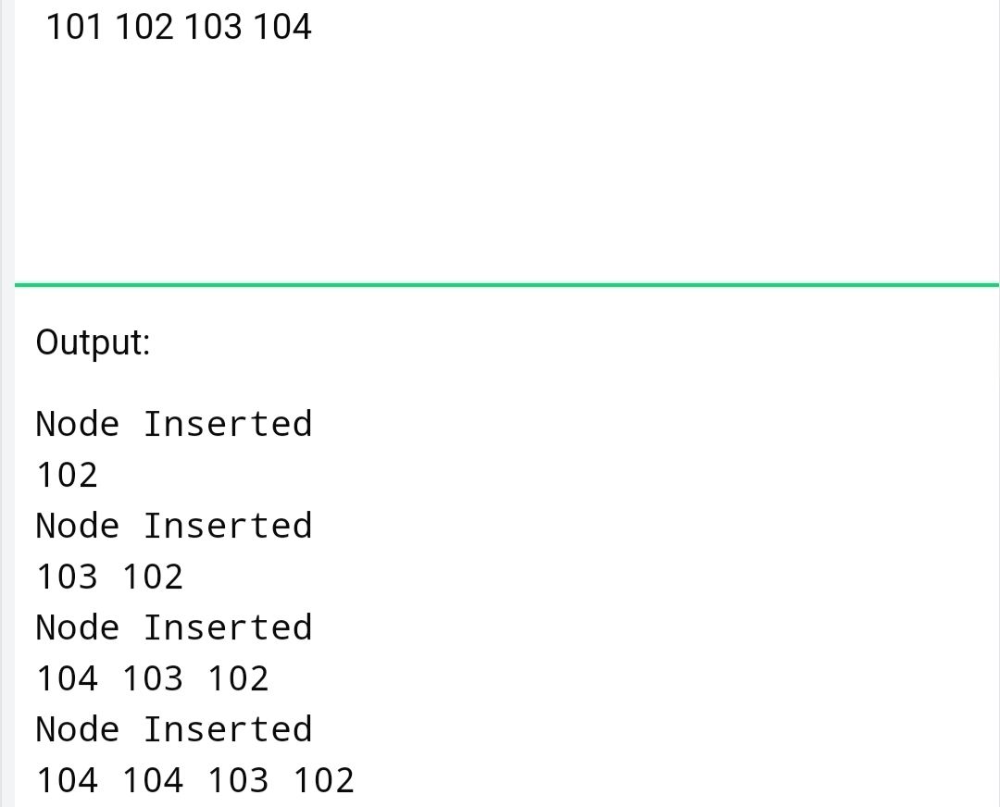

2.Saran is tasked with implementing a doubly linked list in data structures, allowing Users to append elements to the end of the list, and remove the last element. He Needs to ensure efficient memory management in the implementation.Assist him with a suitable program.
#include <iostream>
Using namespace std;

Class Node {
Public:
Int data;
Node* prev;
Node* next;
};

Node* head = NULL;

Void append(int value) {
Node* newNode = new Node();
newNode->data = value;
newNode->next = NULL;

if(head == NULL) {
newNode->prev = NULL;
head = newNode;
return;
}

Node* temp = head;
While(temp->next != NULL) {
Temp = temp->next;
}

Temp->next = newNode;
newNode->prev = temp;
}

Void deleteLast() {
If(head == NULL) return;

If(head->next == NULL) {
Delete head;
Head = NULL;
Return;
}

Node* temp = head;
While(temp->next != NULL) {
Temp = temp->next;
}

Temp->prev->next = NULL;
Delete temp;
}

Void display() {
Node* temp = head;
While(temp != NULL) {
Cout << temp->data << “ “;
Temp = temp->next;
}
}

Int main() {
Int n, x;
Cin >> n;

For(int i = 0; i < n; i++) {
Cin >> x;
Append(x);
}

deleteLast();
display();

return 0;
}
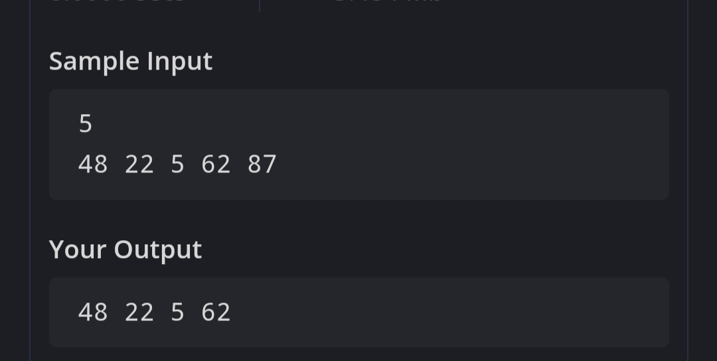

3. Raj is looking for help with a circular linked list challenge! Design a program that creates a circular linked list, then prompts the user to enter a new node's value and the position where it should be inserted. After inserting the new node, display the updated circular linked list to show the changes.

#include <iostream>
Using namespace std;

Class Node {
Public:
Int data;
Node* next;
};

Node* createList(int n) {
Node *head = NULL, *temp, *newNode;

For(int i = 0; i < n; i++) {
Int x;
Cin >> x;

newNode = new Node();
newNode->data = x;

if(head == NULL) {
head = newNode;
newNode->next = head;
temp = head;
} else {
Temp->next = newNode;
Temp = newNode;
Temp->next = head;
}
}
Return head;
}

Node* insertAtPosition(Node* head, int value, int pos) {
Node* newNode = new Node();
newNode->data = value;

if(pos == 1) {
Node* temp = head;
While(temp->next != head)
Temp = temp->next;

newNode->next = head;
temp->next = newNode;
head = newNode;
return head;
}

Node* temp = head;
For(int i = 1; i < pos-1; i++) {
Temp = temp->next;
}

newNode->next = temp->next;
temp->next = newNode;

return head;
}

Void display(Node* head, int count) {
Node* temp = head;
For(int i = 0; i < count; i++) {
Cout << temp->data << “ “;
Temp = temp->next;
}
}

Int main() {
Int n, value, pos;

Cin >> n;
Node* head = createList(n);

Cin >> value;
Cin >> pos;

Head = insertAtPosition(head, value, pos);

Display(head, n + 1);

Return 0;
}
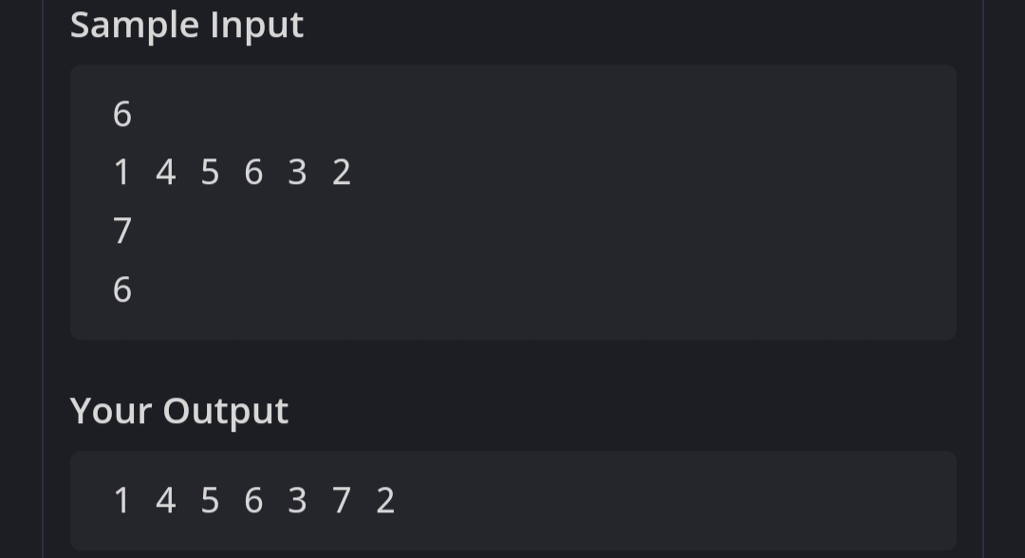

4.In a coding challenge, participants are asked to create a program to handle a circular Linked list representing a queue at a supermarket. The task is to develop a function to remove the last person from the queue where Each customer is identified by a unique identifier. Write a program for the same.

#include <iostream>
Using namespace std;

Class Node{
Public:
Int data;
Node* next;
};

Node* createList(int n){
Node *head=NULL,*temp=NULL,*newNode;

For(int i=0;i<n;i++){
Int x;
Cin>>x;

newNode=new Node();
newNode->data=x;

if(head==NULL){
head=newNode;
temp=newNode;
newNode->next=head;
}
Else{
Temp->next=newNode;
Temp=newNode;
Temp->next=head;
}
}
Return head;
}

Node* deleteLast(Node* head){
If(head==NULL) return head;

If(head->next==head){
Delete head;
Return NULL;
}

Node* temp=head;

While(temp->next->next!=head){
Temp=temp->next;
}

Node* last=temp->next;
Temp->next=head;
Delete last;

Return head;
}

Void display(Node* head){
Node* temp=head;

If(head==NULL) return;

Do{
Cout<<temp->data<<” “;
Temp=temp->next;
}while(temp!=head);
}

Int main(){
Int n;

Cin>>n;

Node* head=createList(n);

Head=deleteLast(head);

Display(head);

Return 0;
}
